PROJECT REPORT

C PROGRAMMING

School of Computer Science
University of Petroleum and Energy Studies

PROJECT TITLE Result Management System (with Ranking & GPA)
• Enter marks of multiple students.
• Calculate GPA/percentage.
• Rank students based on marks.
• Search student records.
• Generate report card to file.

SUBMITTED BY
NAME Shaurya Singhal
SAP ID 590023883
BATCH 60

Instructor: Dr. Prashant Trivedi
Course Code: CSEG1041
VIEW DOCUMENT IN DARK MODE

- WHAT THIS PROJECT DOES

This project develops a result management system in the C programming Language that records student marks and automatically calculates total marks, percentage, GPA, and rank

- WHY IT IS USEFUL

It simplifies the result calculation process by elimination manual errors saving time and providing a clear and accurate evaluation of student performance in a standard manner

- HOW IT WORKS AT A HIGH LEVEL

The system takes student marks as input processes them using functions, arrays, and sorting techniques computes required values and displays the final results along with GPA and ranking in an easy-to-read format

PROBLEM DEFINATION

- MANUAL RESULT CALCULATION IS TIME CONSUMING
in schools and colleges calculating total marks GPA and ranks manually takes a lot of time and effort

- HIGH CHANCE OF HUMAN ERROR
Manual calculation often led to mistakes such as wrong totals incorrect GPA or incorrect ranking

- DIFFICULT IN MANAGING MULTIPLE STUDENTS
Handling multiple student records at the same time becomes complex without a computerized system

- CHALLENGES IN PRESENTING RESULT CLEARLY
Manually prepared result may not be well formatted or easy to understand

- NO AUTOMATIC RANKING SYSTEM
Ranking student based on marks required sorting and comparison which is tedious to do manually

- NEED FOR A STANDARDIZED GPA CALCULATION
Different teachers use different method a program ensures consistent and uniform GPA calculation

FLOWCHART
- ENTER MARKS OF MULTIPLE STUDENT

START

ENTER STUDENT NAME

READ NAME (scanf %99f)

ENTER ROLL NUMBER

READ ROLL (scanf %d)

ENTER MARKS OF 5 SUBJECT

READ 5 MARKS (scanf 5 int)

EXIT

- CALCULATE GPA AND TOTAL FLOWCHART

START

TOTAL MARKS = SUM
PERCENTAGE = SUM / 5.0
SUM = C + LINUX + MATHS + EVS + PROB_SOLVING

MORE STUDENT
I < NUM

EXIT

- OVERALL FLOWCHART
START
ASSIGN RANKS
SORT BY TOATL MARKS
CALCULATE TOTAL MARKS
CALCULATE PERCENTAGE
INPUT LOOP: NAME, ROLL, 5 SUB MARKS
READ NUMBER OF STUDENT

SEARCH RECORD?
(Y/N)
IF NO: FUNCTION
NOT EXECUTED
WRITE ALL RESULT TO “RESULT.txt”
IF YES: SEARCH AND DISPLAY
END

IMPLEMENTATION DETAILS
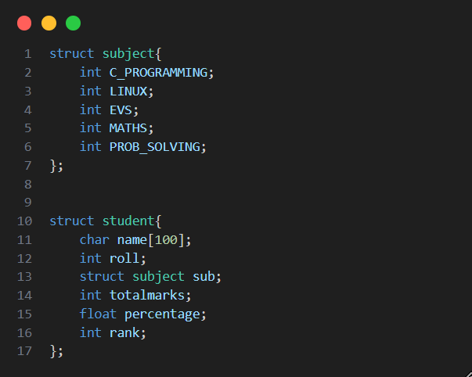
- Data structure

- Read multiple students
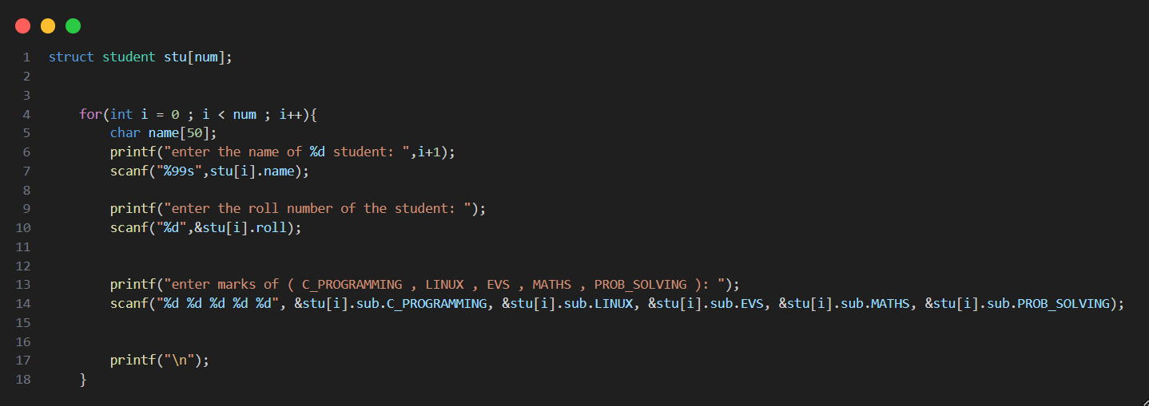

- Sorting and ranking
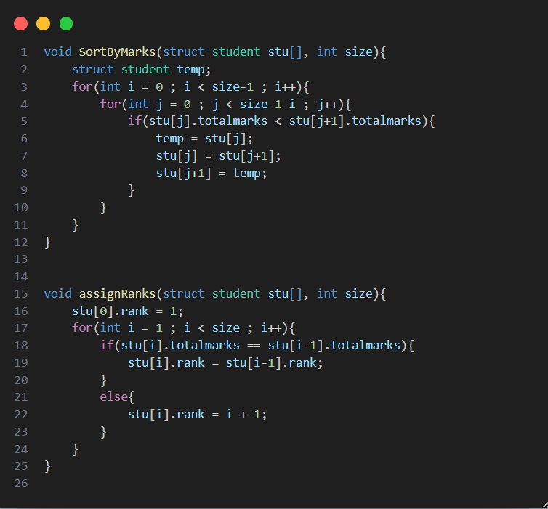

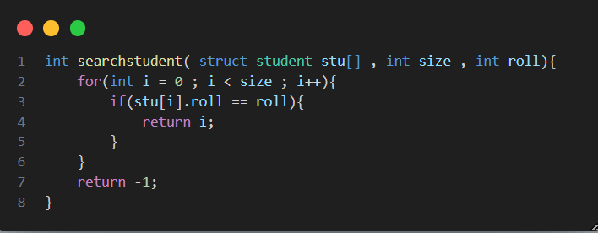
- Search student record by roll

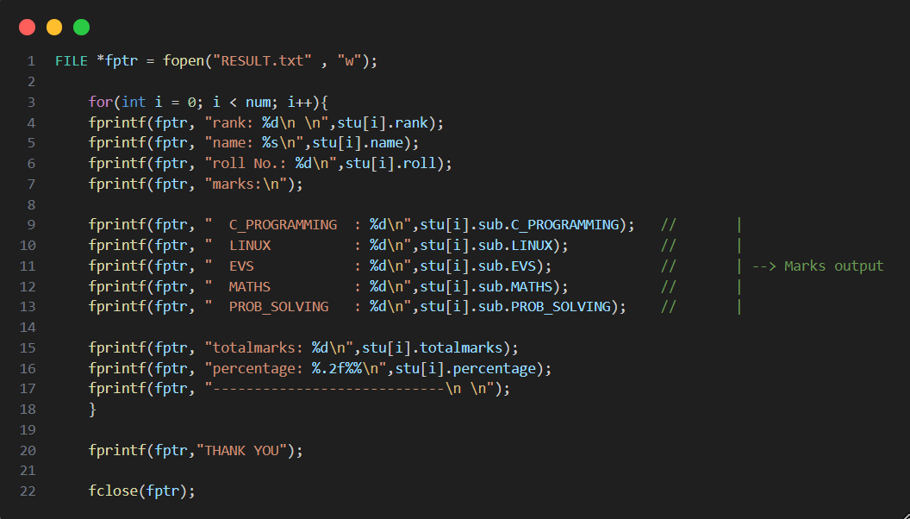
- Generate report file

- Find student record
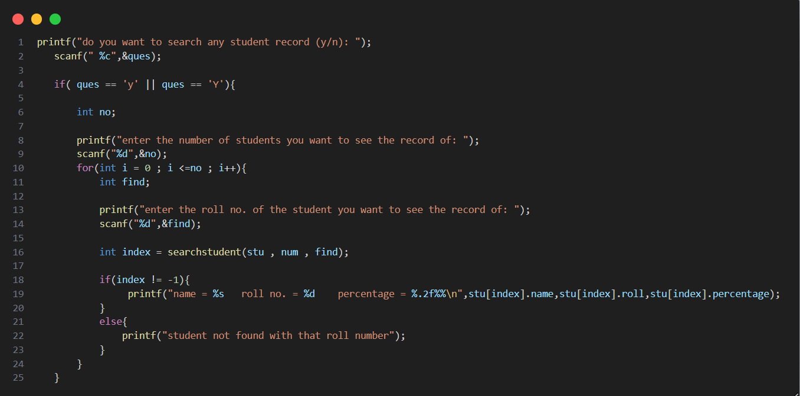

TESTING AND RESULT
- Input
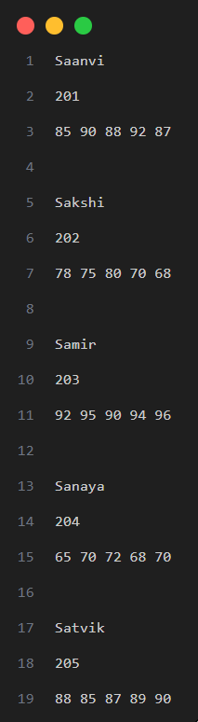
Here we have entered the data of 5 students but we can add data of as many students as we want

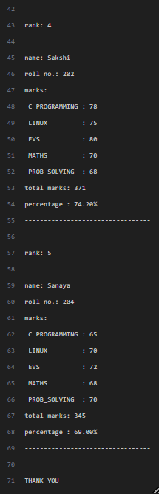
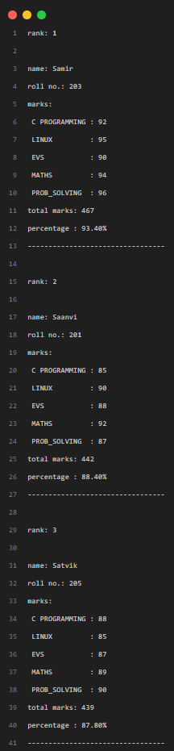
- Result
This the output we will get
CONCLUSION AND FUTURE WORK

- Conclusion

This project helps to calculate student result automatically it takes the marks of each student adds them, find their percentage, GPA, and arrange them in rank order instead of doing everything by hand the program does it quickly and without mistakes it also saves all result in a file so they can be checked later overall the project works well and makes result calculation easier faster and more accurate

- Future work

- A simple menu or graphical interface to make it easier to use
- Saving and loading student data from a file or database
- Exporting results to PDF or Excel
- Adding more subjects more classes or attendance details
- Showing highest marks lowest marks and class average
- Adding option to edit, update, or delete a student record

REFERENCES

- Let Us C
- GeeksforGeeks – “C programming”
- UPES University course material and class notes
- Apna College – “C language tutorial”
Link - https://youtu.be/irqbmMNs2Bo?si=qMkQp-gl-soBy-rn

This concludes the project report on
“Result management system (with ranking and GPA)

THANK YOU.

NAME Shaurya Singhal
SAP ID 590023883
BATCH 60

